A Tour of Google Cloud Hands-on Labs

Overview
Google Cloud is a suite of cloud services hosted on Google's infrastructure. From computing and storage, to data analytics, machine learning, and networking, Google Cloud offers a wide variety of services and APIs that can be integrated with any cloud-computing application or project, from personal to enterprise-grade.
Google Cloud Skills Boost is where you can access Google Cloud’s entire catalog of labs and courses. You can discover learning paths, build in-demand cloud skills, track your activity progress, and validate your knowledge with badges. Qwiklabs is the technology platform the labs and courses sit on. You may see the Qwiklabs name in your Google Cloud learning adventure.
In this introductory-level lab, you take your first steps with Google Cloud by getting hands-on practice with the Cloud Console—an in-browser UI that lets you access and manage Google Cloud services. You will identify key features of Google Cloud and also learn about the details of the lab environment.
If you are new to cloud computing or looking for an overview of Google Cloud and the Qwiklabs platform, you are in the right place. Read on to learn about the specifics of this lab and areas that you will get hands-on practice with.

What you'll learn
In this lab, you will learn about the following:
- The lab platform, and how to identify key features of a lab environment
- How to access the Cloud console with specific credentials
- Google Cloud projects, and identify common misconceptions about them
- How to use the Google Cloud Navigation menu to identify types of Google Cloud services
- Basic roles, and use the Cloud IAM service to inspect actions available to specific users
- The API library, and examine its chief features

Prerequisites
This is an introductory-level lab and the first lab you should take if you're unfamiliar with Google Cloud. If you are already experienced with Cloud console, consider taking one of the following labs:
- Getting Started with Cloud Shell and gcloud
- Creating a Virtual Machine
If you decide to take one, be sure to end this lab now.
If you have a personal or corporate Google Cloud account or project, sign out of that account. If you stay logged in to your personal/corporate account and run the lab in the same browser, your credentials could get confused, resulting in getting logged out of the lab accidentally.
If you are using a Pixelbook, run your lab an Incognito window.

Lab fundamentals

Features and components
Regardless of topic or expertise level, all labs share a common interface. The lab that you're taking should look similar to this:
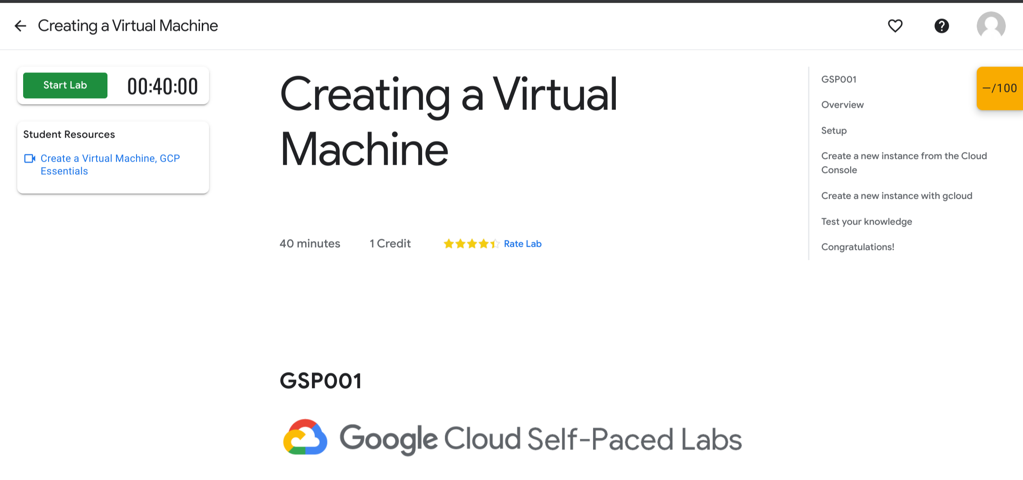

Read the following lab component definitions, and then locate them in the interface.

Start Lab (button)
Clicking this button creates a temporary Google Cloud environment, with all the necessary services and credentials enabled, so you can get hands-on practice with the lab's material. This also starts a countdown timer.

Credit
The price of a lab. 1 Credit is usually equivalent to 1 US dollar (discounts are available when you purchase credits in bulk). Some introductory-level labs (like this one) are free. The more specialized labs cost more because they involve heavier computing tasks and demand more Google Cloud resources.

Time
Specifies the amount of time you have to complete a lab. When you click the Start Lab button, the timer will count down until it reaches 00:00:00. When it does, your temporary Google Cloud environment and resources are deleted. Ample time is given to complete a lab, but make sure you don't work on something else while a lab is running: you risk losing all of your hard work!

Score
Many labs include a score. This feature is called "activity tracking" and ensures that you complete specified steps in a lab. To pass a lab with activity tracking, you need to complete all the steps in order. Only then will you receive completion credit.

Paying for a lab
Some labs are free, but others require you to pay. For those, when you click the Start Lab button, a dialog gives you the choice to launch the lab with an access code or credits. If you don't have either, click Buy credits and follow the instructions.

Reading and following instructions
This browser tab contains the lab instructions. When you start a lab, the Google Cloud console user interface opens in a new browser tab. You will need to switch between the two browser tabs to read the instructions and then perform the tasks. Depending on your physical computer setup, you could also move the two tabs to separate monitors.

Test your understanding
Answer the following multiple choice questions to reinforce your understanding of the concepts we've covered so far.

. Accessing the Cloud Console

Start the lab
- Now that you understand the key features and components of a lab, click Start Lab.
It may take a moment for the Google Cloud environment and credentials to spin up. When the timer starts counting down and the Start Lab button changes to a red End Lab button, everything is in place and you're ready to sign in to the Cloud console.
Note: Do not click the End Lab button until you have completed all the tasks in the lab. When you click the button, your temporary credentials are invalidated and you won't be able to access the work you've done throughout the lab.
You must click this button when you finish; if you do not, you won't be able to take another lab. (The Qwiklabs platform has protections in place to prevent concurrent enrollment.)

Lab details pane
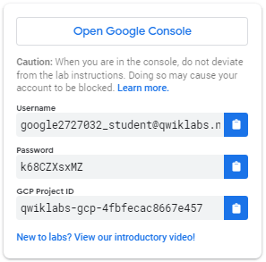
Now that your lab instance is up and running, look at the Lab details pane on the left. It contains an Open Google Console button, credentials (username and password), and a Project ID field.
- The Username from the Lab Details pane automatically fills in. Click Next.
Wait! Make sure to use the googlexxxxxx_student@qwiklabs.net email to sign in, NOT your personal or company email address!
Note: The username that resembles googlexxxxxx_student@qwiklabs.net is a Google account that was created for your use as a student. It has a specific domain name, which is "qwiklabs.net," and has been assigned IAM roles that allow you to access the Google Cloud Project that you have been provisioned.
- Copy the Password from the Lab Connection pane, paste it in the Password field, and click Next.
- Click I understand to indicate your acknowledgement of Google's terms of service and privacy policy.
- On the Welcome page, check Terms of Service to agree to Google Cloud's terms of service, and click Agree and continue.
You've successfully accessed the Cloud Console with your student credentials! Your page should now look like this:
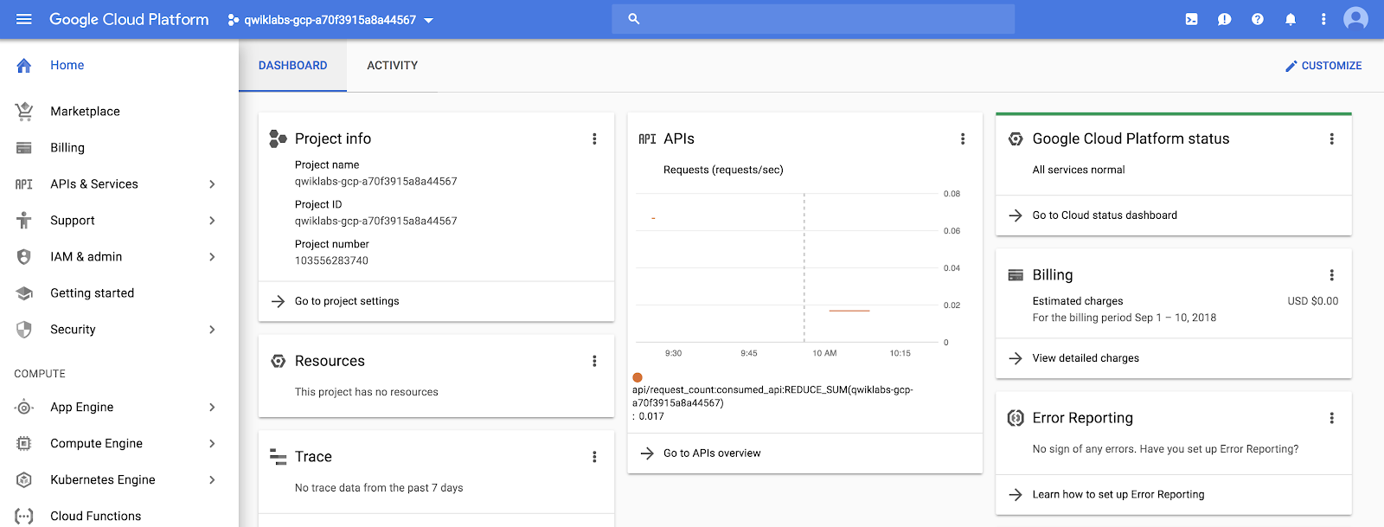

Projects in the Cloud console
Google Cloud projects were explained in the section about the contents of the Lab Connection pane. Here's the definition once again:
A Google Cloud project is an organizing entity for your Google Cloud resources. It often contains resources and services; for example, it may hold a pool of virtual machines, a set of databases, and a network that connects them together. Projects also contain settings and permissions, which specify security rules and who has access to what resources.
The upper-left corner of the central pane contains a card labeled Project info that looks like this:
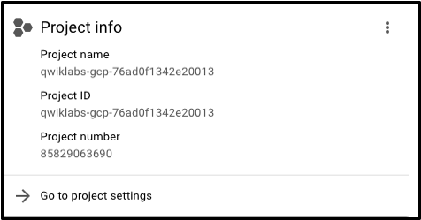

Your project has a name, number, and ID. These identifiers are frequently used when interacting with Google Cloud services. You are working with one project to get experience with a specific service or feature of Google Cloud.

View all projects
You actually have access to more than one Google Cloud project. In fact, in some labs you may be given more than one project in order to complete the assigned tasks.
- In the Google Cloud console title bar, next to your project name, click the drop-down menu.
- In the Select a project dialog, click All. The resulting list of projects includes a "Qwiklabs Resources" project.
Note: Do not switch over to the Qwiklabs Resources project at this point! However, you may need to use it in other labs.
It's not uncommon for large enterprises or experienced users of Google Cloud to have dozens to thousands of Google Cloud projects. Organizations use Google Cloud in different ways, so projects are a good method for organizing cloud computing services (by team or product, for example.)
The "Qwiklabs Resources" project contains files, datasets, and machine images for certain labs and can be accessed from every Google Cloud lab environment. It's important to note that "Qwiklabs Resources" is shared (read only) with all student users, which means that you cannot delete or modify it.
The Google Cloud project that you are working with is temporary, which means that the project and everything it contains will be deleted when the lab ends. Whenever you start a new lab, you will be given access to one or more new Google Cloud projects, and there (not "Qwiklabs Resources") is where you will run all of the lab steps.
- Click Cancel to return to the Cloud overview page.

Navigation menu and services
The Google Cloud console title bar also contains the Navigation menu icon, which appears as three lines:

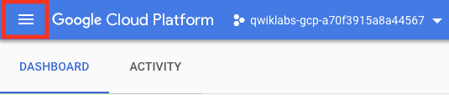
Clicking this icon opens (or hides) the Navigation menu that provides quick access to Google Cloud's core services.
- If the menu isn't open, click Navigation menu.
- Click View all products, then scroll through the categories of tools and services.
This link takes you to documentation that covers each of these categories in more detail.

Task 3. Roles and permissions
In addition to cloud computing services, Google Cloud also contains a collection of permissions and roles that define who has access to what resources. You can use the Cloud Identity and Access Management (Cloud IAM) service to inspect and modify these roles and permissions.

View your roles and permissions
- On the Navigation menu (), click IAM & Admin. This opens a page that contains a list of users and specifies permissions and roles granted to specific accounts.
- Find the student "@qwiklabs" username you signed in with:
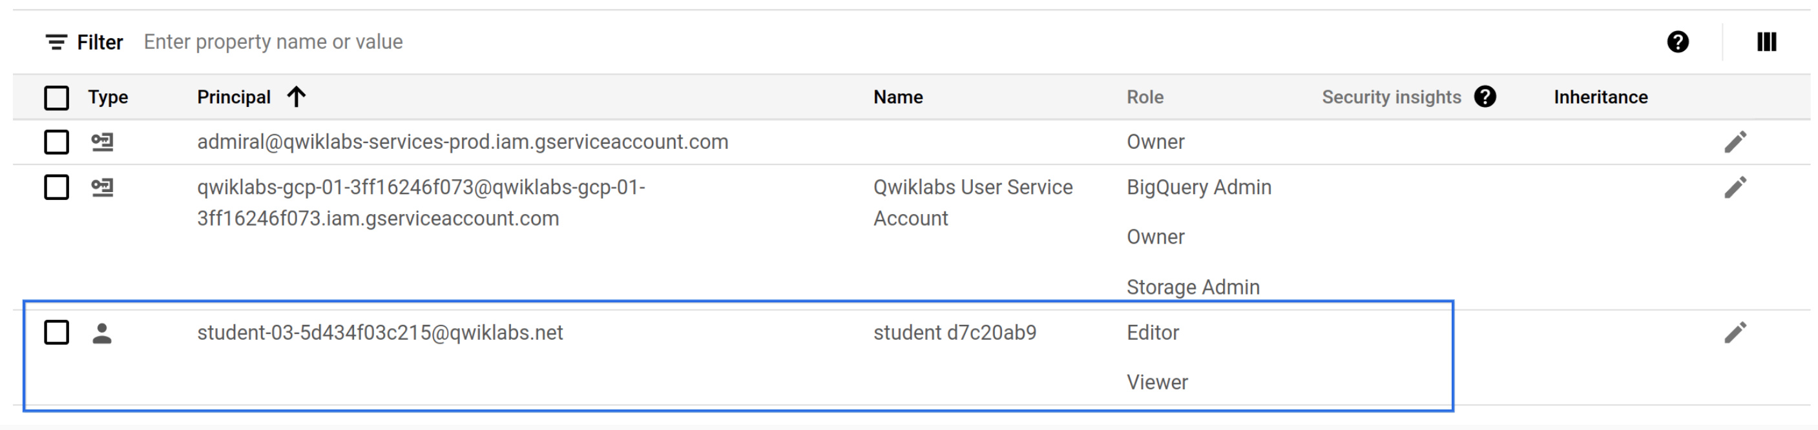
The Principal column displays googlexxxxxx_student@qwiklabs.net (Your matches the username you signed in with). The Name column displays student XXXXXXXX. The Role column displays Editor, which is one of three basic roles offered by Google Cloud. Basic roles set project-level permissions and, unless otherwise specified, control access and management to all Google Cloud services.
The following table pulls definitions from the roles documentation, which gives a brief overview of viewer, editor, and owner role permissions:

Role Name | Permissions
roles/viewer | Permissions for read-only actions that do not affect state, such as viewing (but not modifying) existing resources or data.
roles/editor | All viewer permissions, plus permissions for actions that modify state, such as changing existing resources.
roles/owner | All editor permissions and permissions for the following actions: manage roles and permissions for a project and all resources within the project; set up billing for a project.
As an editor, you can create, modify, and delete Google Cloud resources. However, you can't add or delete members from Google Cloud projects.

Test your understanding

Task 4. APIs and services
Google Cloud APIs are a key part of Google Cloud. Like services, the 200+ APIs, in areas that range from business administration to machine learning, all easily integrate with Google Cloud projects and applications.
APIs are application programming interfaces that you can call directly or via the client libraries. Cloud APIs use resource-oriented design principles as described in the API Design Guide.
When a lab provides a new Google Cloud project for a lab instance, it enables many APIs automatically so you can quickly start work on the lab's tasks. When you create your own Google Cloud projects outside of the lab environment, you will have to enable APIs yourself.
Most Cloud APIs provide you with detailed information on your project’s usage of that API, including traffic levels, error rates, and even latencies, which helps you quickly triage problems with applications that use Google services.
- On the Navigation menu (), click APIs & Services > Library. The left pane, under the header Category, displays the different categories available.
- In the API search bar, type Dialogflow, and then click Dialogflow API. The Dialogflow description page opens.
The Dialogflow API allows you to build rich conversational applications (e.g., for Google Assistant) without having to understand the underlying machine learning and natural language schema.
- Click Enable.
- Click the back button in your browser to verify that the API is now enabled.
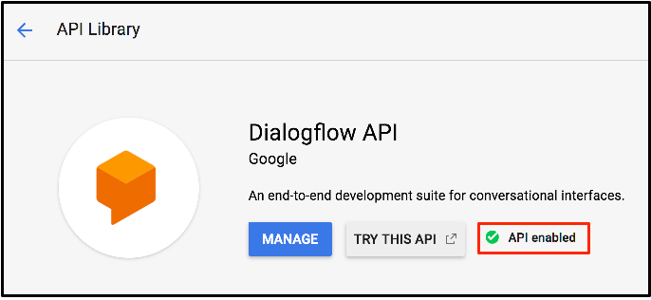
- Click Try this API. A new browser tab displays documentation for the Dialogflow API. Explore this information, and close the tab when you're finished.
- To return to the main page of the Cloud console, on the Navigation menu, click Cloud overview.
Note: You will now encounter a unique feature called Activity Tracking that assesses completion of a task. As you complete tasks and verify these with 'Check my progress' tests, notice that your score increases in the box in the upper right corner. This scoring determines lab completion towards the accomplishment of badges and credentials. Scoring also contributes to leaderboard position in lab games.
In this case, Activity Tracking will verify if you completed enabling the Dialogflow API.
Click Check my progress to verify the objective.

Task 5. Ending your lab
- When you're finished with the lab, click End Lab and then click Submit to confirm it.
- Please rate each lab you take. 
Give the lab five stars if you were satisfied, something less if you weren't. Leave comments about your experiences in the Comment window; Google always appreciates thoughtful feedback.
Ending a lab removes your access to the Google Cloud project and the work you've done in it.
If you return to the Cloud console, you will see that you've been signed out automatically. You can close that tab now.

Congratulations!
In just 30 minutes, you developed a solid understanding of the Cloud console and the platform's key features. You learned about projects, roles, and the types of services the platform offers. You also practiced with Cloud IAM and the API libraries. You are now ready to take more labs.

Finish your quest
This self-paced lab is part of the Google Cloud Essentials and Understanding Your Google Cloud Costs quests. A quest is a series of related labs that form a learning path. Completing a quest earns you a badge to recognize your achievement. You can make your badge or badges public and link to them in your online resume or social media account. Enroll in any quest that contains this lab and get immediate completion credit. Refer to the Google Cloud Skills Boost catalog for all available quests.

Take your next lab
Continue your quest with Creating a Virtual Machine, or check out these other Google Cloud Skills Boost labs:
- Compute Engine: Qwik Start - Windows
- Getting Started with Cloud Shell and gcloud

Google Cloud training and certification
...helps you make the most of Google Cloud technologies. Our classes include technical skills and best practices to help you get up to speed quickly and continue your learning journey. We offer fundamental to advanced level training, with on-demand, live, and virtual options to suit your busy schedule. Certifications help you validate and prove your skill and expertise in Google Cloud technologies.
Manual Last Updated December 12, 2022
Lab Last Tested December 12, 2022
Copyright 2023 Google LLC All rights reserved. Google and the Google logo are trademarks of Google LLC. All other company and product names may be trademarks of the respective companies with which they are associated.

Getting Started with Cloud Shell and gcloud

Overview
Cloud Shell provides you with command-line access to computing resources hosted on Google Cloud. Cloud Shell is a Debian-based virtual machine with a persistent 5-GB home directory, which makes it easy for you to manage your Google Cloud projects and resources. The gcloud command-line tool and other utilities you need are pre-installed in Cloud Shell, which allows you to get up and running quickly.
In this hands-on lab, you learn how to connect to computing resources hosted on Google Cloud via Cloud Shell with the gcloud tool.
You are encouraged to type the commands themselves, which reinforces the core concepts. Many labs will include a code block that contains the required commands. You can easily copy and paste the commands from the code block into the appropriate places during the lab.

What you'll do
- Practice using gcloud commands.
- Connect to compute services hosted on Google Cloud.

Prerequisites
- Familiarity with standard Linux text editors such as vim, emacs, or nano.
Before you click the Start Lab button
Read these instructions. Labs are timed and you cannot pause them. The timer, which starts when you click Start Lab, shows how long Google Cloud resources will be made available to you.
This hands-on lab lets you do the lab activities yourself in a real cloud environment, not in a simulation or demo environment. It does so by giving you new, temporary credentials that you use to sign in and access Google Cloud for the duration of the lab.
To complete this lab, you need:
- Access to a standard internet browser (Chrome browser recommended).

How to start your lab and sign in to the Google Cloud Console
- Click the Start Lab button. If you need to pay for the lab, a pop-up opens for you to select your payment method. On the left is the Lab Details panel with the following:
  - The Open Google Console button
  - Time remaining
  - The temporary credentials that you must use for this lab
  - Other information, if needed, to step through this lab
- Click Open Google Console. The lab spins up resources, and then opens another tab that shows the Sign in page.
Tip: Arrange the tabs in separate windows, side-by-side.
Note: If you see the Choose an account dialog, click Use Another Account.
- If necessary, copy the Username from the Lab Details panel and paste it into the Sign in dialog. Click Next.
- Copy the Password from the Lab Details panel and paste it into the Welcome dialog. Click Next.
Important: You must use the credentials from the left panel. Do not use your Google Cloud Skills Boost credentials.Note: Using your own Google Cloud account for this lab may incur extra charges.
- Click through the subsequent pages:
  - Accept the terms and conditions.
  - Do not add recovery options or two-factor authentication (because this is a temporary account).
  - Do not sign up for free trials.
After a few moments, the Cloud Console opens in this tab.
Note: You can view the menu with a list of Google Cloud Products and Services by clicking the Navigation menu at the top-left.

Activate Cloud Shell
Cloud Shell is a virtual machine that is loaded with development tools. It offers a persistent 5GB home directory and runs on the Google Cloud. Cloud Shell provides command-line access to your Google Cloud resources.
- Click Activate Cloud Shell at the top of the Google Cloud console.
When you are connected, you are already authenticated, and the project is set to your PROJECT_ID. The output contains a line that declares the PROJECT_ID for this session:
Your Cloud Platform project in this session is set to YOUR_PROJECT_ID
gcloud is the command-line tool for Google Cloud. It comes pre-installed on Cloud Shell and supports tab-completion.
- (Optional) You can list the active account name with this command:
gcloud auth list
Copied!
- Click Authorize.
- Your output should now look like this:
Output:
ACTIVE: *
ACCOUNT: student-01-xxxxxxxxxxxx@qwiklabs.net
To set the active account, run:
$ gcloud config set account `ACCOUNT`
- (Optional) You can list the project ID with this command:
gcloud config list project
Copied!
Output:
[core]
project = <project_ID>
Example output:
[core]
project = qwiklabs-gcp-44776a13dea667a6
Note: For full documentation of gcloud, in Google Cloud, refer to the gcloud CLI overview guide.
After Cloud Shell is activated, you can use the command line to invoke the Cloud SDK gcloud tool or other tools available on the virtual machine instance. Later in the lab, you will use your $HOME directory, which is used in persistent disk storage to store files across projects and between Cloud Shell sessions. Your $HOME directory is private to you and cannot be accessed by other users.
Task 1. Configuring your environment
In this section, you'll learn about aspects of the development environment that you can adjust.

Understanding regions and zones
Certain Google Compute Engine resources live in regions or zones. A region is a specific geographical location where you can run your resources. Each region has one or more zones. For example, the us-central1 region denotes a region in the Central United States that has zones us-central1-a, us-central1-b, us-central1-c, and us-central1-f. The following table shows zones in their respective regions:
Western US | Central US | Eastern US | Western Europe | Eastern Asia
us-west1-a | us-central1-a | us-east1-b | europe-west1-b | asia-east1-a
us-west1-b | us-central1-b | us-east1-c | europe-west1c | asia-east1-b
- | us-central1-c | us-east1-d | europe-west1-d | aisia-east1-c
- | us-central1-f | - | - | -
Resources that live in a zone are referred to as zonal resources. Virtual machine instances and persistent disks live in a zone. If you want to attach a persistent disk to a virtual machine instance, both resources must be in the same zone. Similarly, if you want to assign a static IP address to an instance, the instance must be in the same region as the static IP address.
Note: Learn more about regions and zones and see a complete list in Google Cloud Compute Engine's Regions and Zones documentation.
- Set the region to us-west1
gcloud config set compute/region us-west1
Copied!
- To view the project region setting, run the following command:
gcloud config get-value compute/region
Copied!
- Set the zone to us-west1-a :
gcloud config set compute/zone us-west1-a
Copied!
- To view the project zone setting, run the following command:
gcloud config get-value compute/zone
Copied!

Finding project information
- Copy your project ID to your clipboard or text editor. The project ID is listed in 2 places:
  - In the Cloud Console, on the Dashboard, under Project info. (Click Navigation menu (), and then click Cloud overview > Dashboard.)
  - On the lab tab near your username and password.
- In Cloud Shell, run the following gcloud command, to view the project id for your project:
gcloud config get-value project
Copied!
- In Cloud Shell, run the following gcloud command to view details about the project:
gcloud compute project-info describe --project $(gcloud config get-value project)
Copied!
Find the zone and region metadata values in the output. You'll use the zone (google-compute-default-zone) from the output later in this lab.
Note: When the google-compute-default-region and google-compute-default-zone keys and values are missing from the output, no default zone or region is set. The output includes other useful information regarding your project. Take some time to explore this in more detail.

Setting environment variables
Environment variables define your environment and help save time when you write scripts that contain APIs or executables.
- Create an environment variable to store your Project ID:
export PROJECT_ID=$(gcloud config get-value project)
Copied!
- Create an environment variable to store your Zone:
export ZONE=$(gcloud config get-value compute/zone)
Copied!
- To verify that your variables were set properly, run the following commands:
echo -e "PROJECT ID: $PROJECT_ID\nZONE: $ZONE"
Copied!
If the variables were set correctly, the echo commands will output your Project ID and Zone.

Creating a virtual machine with the gcloud tool
Use the gcloud tool to create a new virtual machine (VM) instance.
- To create your VM, run the following command:
gcloud compute instances create gcelab2 --machine-type e2-medium --zone $ZONE
Copied!
Output:
Command details
- gcloud compute allows you to manage your Compute Engine resources in a format that's simpler than the Compute Engine API.
- instances create creates a new instance.
- gcelab2 is the name of the VM.
- The --machine-type flag specifies the machine type as e2-medium.
- The --zone flag specifies where the VM is created.
- If you omit the --zone flag, the gcloud tool can infer your desired zone based on your default properties. Other required instance settings, such as machine type and image, are set to default values if not specified in the create command.

Test completed task
Click Check my progress to verify your performed task. If you have successfully created a virtual machine with the gcloud tool, an assessment score is displayed.
Assessment Completed!
Assessment Completed!

  - To open help for the create command, run the following command:
gcloud compute instances create --help
Copied!
Note: Press Enter or the spacebar to scroll through the help content. To exit the content, type Q.

Exploring gcloud commands
The gcloud tool offers simple usage guidelines that are available by adding the -h flag (for help) onto the end of any gcloud command.
- Run the following command:
gcloud -h
Copied!
You can access more verbose help by appending the --help flag onto a command or running the gcloud help command.
- Run the following command:
gcloud config --help
Copied!
To exit type Q and hit Enter.
- Run the following command:
gcloud help config
Copied!
The results of the gcloud config --help and gcloud help config commands are equivalent. Both return long, detailed help.
There are global flags in gcloud that govern the behavior of commands on a per-invocation level. Flags override any values set in SDK properties.
- View the list of configurations in your environment:
gcloud config list
Copied!
- To see all properties and their settings:
gcloud config list --all
Copied!
- List your components:
gcloud components list
Copied!
This command displays the gcloud components that are ready for you to use in this lab.

- Assessment Completed!
Assessment Completed!

  - To open help for the create command, run the following command:
gcloud compute instances create --help
Copied!
Note: Press Enter or the spacebar to scroll through the help content. To exit the content, type Q.

Exploring gcloud commands
The gcloud tool offers simple usage guidelines that are available by adding the -h flag (for help) onto the end of any gcloud command.
- Run the following command:
gcloud -h
Copied!
You can access more verbose help by appending the --help flag onto a command or running the gcloud help command.
- Run the following command:
gcloud config --help
Copied!
To exit type Q and hit Enter.
- Run the following command:
gcloud help config
Copied!
The results of the gcloud config --help and gcloud help config commands are equivalent. Both return long, detailed help.
There are global flags in gcloud that govern the behavior of commands on a per-invocation level. Flags override any values set in SDK properties.
- View the list of configurations in your environment:
gcloud config list
Copied!
- To see all properties and their settings:
gcloud config list --all
Copied!
- List your components:
gcloud components list
Copied!
This command displays the gcloud components that are ready for you to use in this lab.

Task 2. Filtering command-line output
The gcloud command-line interface (CLI) is a powerful tool for working at the command line. You may want specific information to be displayed.
- List the compute instance available in the project:
gcloud compute instances list
Copied!
Note: Having multiple resources deployed in a project is very common. Fortunately gcloud has some clever formatting that can help identify specific resources.
Example Output:
NAME: gcelab2
ZONE: us-west1-a
MACHINE_TYPE: e2-medium
PREEMPTIBLE:
INTERNAL_IP: 10.142.0.2
EXTERNAL_IP: 35.237.43.111
STATUS: RUNNING
- List the gcelab2 virtual machine:
gcloud compute instances list --filter="name=('gcelab2')"
Copied!
Example Output:
NAME: gcelab2
ZONE: us-west1-a
MACHINE_TYPE: e2-medium
PREEMPTIBLE:
INTERNAL_IP: 10.142.0.2
EXTERNAL_IP: 35.237.43.111
STATUS: RUNNING
In the above command, we have asked gcloud to only show the information matching the criteria i.e. a virtual instance name matching the criteria.
- List the firewall rules in the project:
gcloud compute firewall-rules list
Copied!
Output:
NAME NETWORK DIRECTION PRIORITY ALLOW DENY DISABLED
default-allow-icmp default INGRESS 65534 icmp False
default-allow-internal default INGRESS 65534 tcp:0-65535,udp:0-65535,icmp False
default-allow-rdp default INGRESS 65534 tcp:3389 False
default-allow-ssh default INGRESS 65534 tcp:22 False
dev-net-allow-ssh dev-network INGRESS 1000 tcp:22 False
serverless-to-vpc-connector dev-network INGRESS 1000 icmp,udp:665-666,tcp:667 False
vpc-connector-egress dev-network INGRESS 1000 icmp,udp,tcp False
vpc-connector-health-check dev-network INGRESS 1000 tcp:667 False
vpc-connector-to-serverless dev-network EGRESS 1000 icmp,udp:665-666,tcp:667 False
- List the firewall rules for the default network:
gcloud compute firewall-rules list --filter="network='default'"
Copied!
Output:
NAME NETWORK DIRECTION PRIORITY ALLOW DENY DISABLED
default-allow-icmp default INGRESS 65534 icmp False
default-allow-internal default INGRESS 65534 tcp:0-65535,udp:0-65535,icmp False
default-allow-rdp default INGRESS 65534 tcp:3389 False
default-allow-ssh default INGRESS 65534 tcp:22 False
- List the firewall rules for the default network where the allow rule matches an ICMP rule:
gcloud compute firewall-rules list --filter="NETWORK:'default' AND ALLOW:'icmp'"
Copied!
Output:
NAME NETWORK DIRECTION PRIORITY ALLOW DENY DISABLED
default-allow-icmp default INGRESS 65534 icmp False
default-allow-internal default INGRESS 65534 tcp:0-65535,udp:0-65535,icmp False
Task 3. Connecting to your VM instance
gcloud compute makes connecting to your instances easy. The gcloud compute ssh command provides a wrapper around SSH, which takes care of authentication and the mapping of instance names to IP addresses.
- To connect to your VM with SSH, run the following command:
gcloud compute ssh gcelab2 --zone $ZONE
Copied!
Output:
WARNING: The public SSH key file for gcloud does not exist.
WARNING: The private SSH key file for gcloud does not exist.
WARNING: You do not have an SSH key for gcloud.
WARNING: [/usr/bin/ssh-keygen] will be executed to generate a key.
This tool needs to create the directory
[/home/gcpstaging306_student/.ssh] before being able to generate SSH Keys.
Do you want to continue? (Y/n)
- To continue, type Y.
Generating public/private rsa key pair.
Enter passphrase (empty for no passphrase)
- To leave the passphrase empty, press Enter twice.
Note: You have connected to the virtual machine created earlier in the lab. Did you notice how the command prompt changed?
The prompt now says something similar to sa_107021519685252337470@gcelab2.
  - The reference before the @ indicates the account being used.
  - After the @ sign indicates the host machine being accessed.
- Install nginx web server on to virtual machine:
sudo apt install -y nginx
Copied!
- You don't need to do anything here; so to disconnect from SSH and exit the remote shell, run the following command:
exit
Copied!
You should be back at your project's command prompt.
Task 4. Updating the firewall
When using compute resources such as virtual machines, it's important to understand the associated firewall rules.
- List the firewall rules for the project:
gcloud compute firewall-rules list
Copied!
Output:
NAME NETWORK DIRECTION PRIORITY ALLOW DENY DISABLED
default-allow-icmp default INGRESS 65534 icmp False
default-allow-internal default INGRESS 65534 tcp:0-65535,udp:0-65535,icmp False
default-allow-rdp default INGRESS 65534 tcp:3389 False
default-allow-ssh default INGRESS 65534 tcp:22 False
dev-net-allow-ssh dev-network INGRESS 1000 tcp:22 False
serverless-to-vpc-connector dev-network INGRESS 1000 icmp,udp:665-666,tcp:667 False
vpc-connector-egress dev-network INGRESS 1000 icmp,udp,tcp False
vpc-connector-health-check dev-network INGRESS 1000 tcp:667 False
vpc-connector-to-serverless dev-network EGRESS 1000 icmp,udp:665-666,tcp:667 False
From the above we can see we have two networks available. The default network is where our virtual machine gcelab2 is located.
- Try to access the nginx service running on the gcelab2 virtual machine.
Note: Communication with the virtual machine will fail as it does not have an appropriate firewall rule. Our nginx web server is expecting to communicate on tcp:80. To get communication working we need to:
  - Add a tag to the gcelab2 virtual machine
  - Add a firewall rule for http traffic
- Add a tag to the virtual machine:
gcloud compute instances add-tags gcelab2 --tags http-server,https-server
Copied!
- Update the firewall rule to allow:
gcloud compute firewall-rules create default-allow-http --direction=INGRESS --priority=1000 --network=default --action=ALLOW --rules=tcp:80 --source-ranges=0.0.0.0/0 --target-tags=http-server
Copied!
- List the firewall rules for the project:
gcloud compute firewall-rules list --filter=ALLOW:'80'
Copied!
Output:
NAME NETWORK DIRECTION PRIORITY ALLOW DENY DISABLED
default-allow-http default INGRESS 1000 tcp:80 False
- Verify communication is possible for http to the virtual machine:
curl http://$(gcloud compute instances list --filter=name:gcelab2 --format='value(EXTERNAL_IP)')
Copied!
You will see the default nginx output.

Task 5. Viewing the system logs
Viewing logs is essential to understanding the working of your project. Use gcloud to access the different logs available on Google Cloud.
- View the available logs on the system:
gcloud logging logs list
Copied!
Output:
NAME: projects/qwiklabs-gcp-01-4b75909db302/logs/GCEGuestAgent
NAME: projects/qwiklabs-gcp-01-4b75909db302/logs/OSConfigAgent
NAME: projects/qwiklabs-gcp-01-4b75909db302/logs/autoscaler.googleapis.com%2Fstatus_change
NAME: projects/qwiklabs-gcp-01-4b75909db302/logs/cloudaudit.googleapis.com%2Factivity
NAME: projects/qwiklabs-gcp-01-4b75909db302/logs/cloudaudit.googleapis.com%2Fdata_access
NAME: projects/qwiklabs-gcp-01-4b75909db302/logs/cloudaudit.googleapis.com%2Fsystem_event
NAME: projects/qwiklabs-gcp-01-4b75909db302/logs/compute.googleapis.com%2Fautoscaler
NAME: projects/qwiklabs-gcp-01-4b75909db302/logs/compute.googleapis.com%2Finstance_group_manager_events
NAME: projects/qwiklabs-gcp-01-4b75909db302/logs/compute.googleapis.com%2Fshielded_vm_integrity
NAME: projects/qwiklabs-gcp-01-4b75909db302/logs/run.googleapis.com%2Fstderr
NAME: projects/qwiklabs-gcp-01-4b75909db302/logs/run.googleapis.com%2Fstdout
- View the logs that relate to compute resources:
gcloud logging logs list --filter="compute"
Copied!
Output:
NAME: projects/qwiklabs-gcp-01-4b75909db302/logs/compute.googleapis.com%2Fautoscaler
NAME: projects/qwiklabs-gcp-01-4b75909db302/logs/compute.googleapis.com%2Finstance_group_manager_events
NAME: projects/qwiklabs-gcp-01-4b75909db302/logs/compute.googleapis.com%2Fshielded_vm_integrity
- Read the logs related to the resource type of gce_instance:
gcloud logging read "resource.type=gce_instance" --limit 5
Copied!
- Read the logs for a specific virtual machine:
gcloud logging read "resource.type=gce_instance AND labels.instance_name='gcelab2'" --limit 5
Copied!

